**AWS CLI:**

* Download AWS CLI from google for windows and install it
* Then generate access key, secret key from AWS console

Open AWS CLI, then execute below command

* **Aws configure**

After this, it will ask for access key and secret key & region name then enter

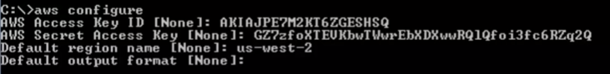

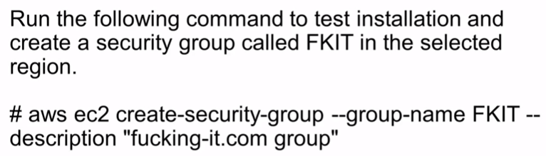

* Then go back to console and check if security group created